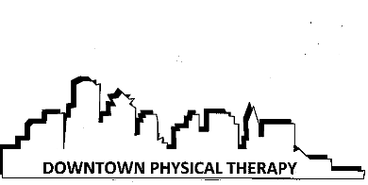

PATIENT REFERRAL AND BENFIT POLICY
All patients are responsible for contacting their insurance company to find out if they need a referral or an authorizations in order for their PT treatment to be covered. In the case that the patient fails to obtain the necessary authorization the patient will be responsible for payment.

It is the patient’s responsibility to contact their insurance company to inquire about the out of pocket expenses the patient might incur due to PT treatment. The amount quoted by the staff at Healthy Edge Physical Therapy is just an estimate based on the type of insurance plan, not guarantee of benefits. The patient must call their insurance company to see if a copayment or deductible apply. Any out of pocket expenses incurred, based on your insurance contract, will be the responsibility of the patient regardless of whether they were aware of the cost prior to treatment.

If the insurance requires a patient to pay a large sum out of pocket and they are having trouble understanding their balance, the patient can contact our office and we will be happy to go over the expenses with you. If the patient is unable to pay their balance in full we will be happy to work out a payment plan.

Signature ____________________________________________________ Date _____________

